Q.N.1) Design a system for jewelry shop. Jewelry shop offers 3 types of memberships: Premium, Gold and Silver. Premium, gold and silver members receive a discount of 10%, 8%, and 5%, respectively, for all jewelry provided.Customers without membership receive no discount. The system should capable to  compute the total bill if a customer purchases x number of jewelry sets.

* 1. Use OOP concept to design the system.
  2. Take input for all kinds of customers and print total bill for each customer.

Ans.

import java.util.Scanner;

public abstract class Shop {

abstract void Discount();

double value,dis,total;

public void Shop(double v){

this.value = v;

}

}

class Premium extends Shop{

void Discount() {

dis = value*0.1;

System.out.println("Received 10% Discount= "+dis);

total = value-dis;

System.out.println("\nTotal Payable Amount is= " +total );

}

}

class Gold extends Shop{

void Discount() {

dis = value*0.08;

System.out.println("Received 8% Discount= "+dis);

total = value-dis;

System.out.println("\nTotal Payable Amount is= " +total );

}

}

class Silver extends Shop{

void Discount() {

dis = value*0.05;

System.out.println("Received 5% Discount= " +dis);

total = value-dis;

System.out.println("\nTotal Payable Amount is= " +total );

}

}

class apple{

public static void main(String[] args) {

System.out.println("1.Premium ");

System.out.println("\n2.Gold");

System.out.println("\n3.Silver");

System.out.println("\n4.Not Member");

System.out.println("\nSelect Membership= ");

Scanner s = new Scanner(System.in);

int a = s.nextInt();

Premium z = new Premium();

Gold y = new Gold();

Silver x = new Silver();

if(a==1) {

System.out.println("Enter the Value of Jewelry=");

double j = s.nextDouble();

z.Shop(j);

z.Discount();

}

else if(a==2) {

System.out.println("Enter the Value of Jewelry=");

double j = s.nextDouble();

y.Shop(j);

y.Discount();

}

else if(a==3){

System.out.println("Enter the Value of Jewelry=");

double j = s.nextDouble();

x.Shop(j);

x.Discount();

}

else {

System.out.println("Enter the Value of Jewelry=");

double j = s.nextDouble();

System.out.println("No Discount Received");

System.out.println("Total Amount Payable is= "+j);

}

}}

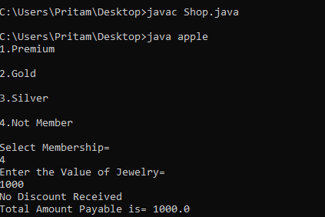 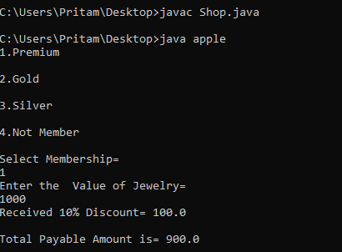

Q.N.2) Design a Tuition Management System. Consider an Education Institute, where task is distributed between owner, lecturers and helpers.

Task of Tuition owner :-

Take admission of students

Log the lecture hours of subject teachers

Take lectures

Calculate and pay the fees of staff

Accept the fees from students

Can read books from library

Can enter courses and fee details

Task of Subject teachers :-

Take lectures

Accept the fees from students

Can read books from the Library

Task of helper/tutor :-

Solve difficulties of students

Can read books from the library

Task of students

Attend lectures

Can read books from the library

Create a basic design or structure of system by considering above tasks. Do not apply any logic or any calculation. No user interaction is required.Just design the skeleton using the OOP concept. Explain each concept applied in solution.

Ans.

**import** java.util.*;

**abstract** **public** **class** Institute {

**abstract** **void** ins();

}

**class** Owner **extends** Institute{

**void** ins() { System.***out***.println("Enter Details For Admission"); }

**void** ins(**int** d) { System.***out***.println("Log the lecture hour");}

**void** ins(**double** aa) { System.***out***.println("Take Lecture");}

**void** a() {System.***out***.println("Calculate and pay fee of Staff");}

**void** a(**int** a) {System.***out***.println("Accept Fees");}

**void** a(**double** a) {System.***out***.println("Read Book from Library");}

**void** b() {System.***out***.println("Enter Course & fee Details");}

}

**class** Lecturer **extends** Institute{

**void** ins() { System.***out***.println("Take Lectures");}

**void** ins(**int** d) { System.***out***.println("Accept the fees from students");}

**void** ins(**double** d) { System.***out***.println("Can read books from the library");}

}

**class** Helper **extends** Institute{

**void** ins() {System.***out***.println("Solve difficulties of students");}

**void** ins(**int** d) { System.***out***.println("an read books from the library");}

}

**class** Students **extends** Institute{

**void** ins(){ System.***out***.println("Attend lectures");}

**void** ins(**int** d) { System.***out***.println("Can read books from the library");}

}

**class** ball{

**public** **static** **void** main(String[] args) {

System.***out***.println("Choose Your Designation");

System.***out***.println("\n1.Owner");

System.***out***.println("2.Lecturer");

System.***out***.println("3.Helper");

System.***out***.println("4.Students");

Scanner sc = **new** Scanner(System.***in***);

**int** a = sc.nextInt();

Owner obj1 = **new** Owner();

Lecturer obj2 = **new** Lecturer();

Helper obj3 = **new** Helper();

Students obj4 = **new** Students();

**if**(a==1) {

System.***out***.println("\n1.Take Admission of Students");

System.***out***.println("2.Log Lecture hours of Teacher");

System.***out***.println("3.Take Lecture");

System.***out***.println("4.Calculate and pay fee of Staff ");

System.***out***.println("5.Accept Fees");

System.***out***.println("6.Read Book from Library");

System.***out***.println("7.Enter Course & fee Details");

**int** b = sc.nextInt();

**if**(b==1){ obj1.ins(); }

**if**(b==2) { obj1.ins(2);}

**if**(b==3) { obj1.ins(1.55); }

**if**(b==4) { obj1.a(); }

**if**(b==5) {obj1.a(1);}

**if**(b==6) {obj1.a(2.2);}

**if**(b==7) {obj1.b();}

}

**if**(a==2) {

System.***out***.println("1.Take lectures");

System.***out***.println("2.Accept the fees from students");

System.***out***.println("3.Can read books from the library");

**int** b = sc.nextInt();

**if**(b==1){ obj2.ins(); }

**if**(b==2) { obj2.ins(2);}

**if**(b==3) { obj2.ins(1.55); }

}

**if**(a==3) {

System.***out***.println("1.Solve difficulties of students");

System.***out***.println("2.Can read books from the library");

**int** b = sc.nextInt();

**if**(b==1){ obj3.ins(); }

**if**(b==2) { obj3.ins(2);}

}

**if**(a==4) {

System.***out***.println("1.Attend lectures");

System.***out***.println("2.Can read books from the library");

**int** b = sc.nextInt();

**if**(b==1){ obj4.ins(); }

**if**(b==2) { obj4.ins(2);}

}

}

} **OUTPUT**

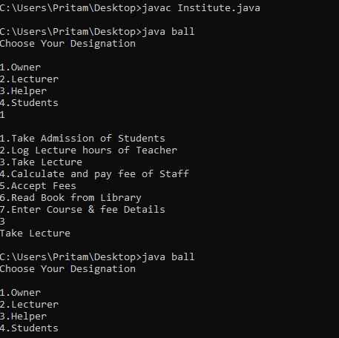

Q.N.3) Create a solution to offer a different kind of Courses for above institute (exercise 2). All courses have a name, duration and course fee. Some courses are part time, where you have to store the timing for course. Some courses are full time. For full time course take a charge 10% more on the course fee. For part-time course, give 10% discount. Enter 2 example courses and print its total fees for 2 student.

Ans.